2022 SAS Optimization Challenge

**Optimal Solution for Minimizing Water Cost**

For XYZ Corporation

Solution Write-up

January 2022

Cheng-Yu Chen

JOS

consultant

Ting-Yun Cheng

Xue Han

**Objective 1 – Forecasting**

* Preprocessing

The raw data contains two different kinds of meters, cooling and main. Thus, we combine the two meters by date and convert them into time series data.

* 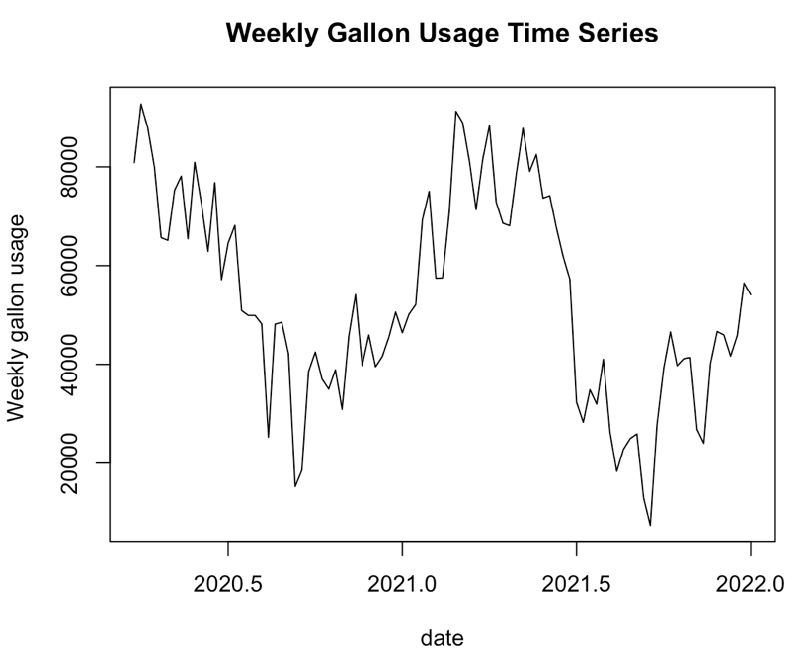Models:

We apply the time series data with 8 time series models.

1. Linear trend model
2. Quadratic trend model
3. Exponential trend model
4. Linear trend model with seasonality
5. Quadratic trend model with seasonality
6. Exponential trend model with seasonality
7. ARIMA
8. Exponential smoothing with seasonality TBATS model

* Model Evaluation:

The time series data is split into 90% training set (83 weeks) and 10% test set (10 weeks). We selected Exponential smoothing with seasonality TBATS model for future prediction because the model has the smallest ME, RMSE, MAE, MPE, MAPE, MASE on test set which means its prediction is the best among other models.

The cross-validation of each model:

1. Linear trend model



1. Quadratic trend model



1. Exponential trend model



1. Linear trend model with seasonality

1. Quadratic trend model with seasonality

1. Exponential trend model with seasonality

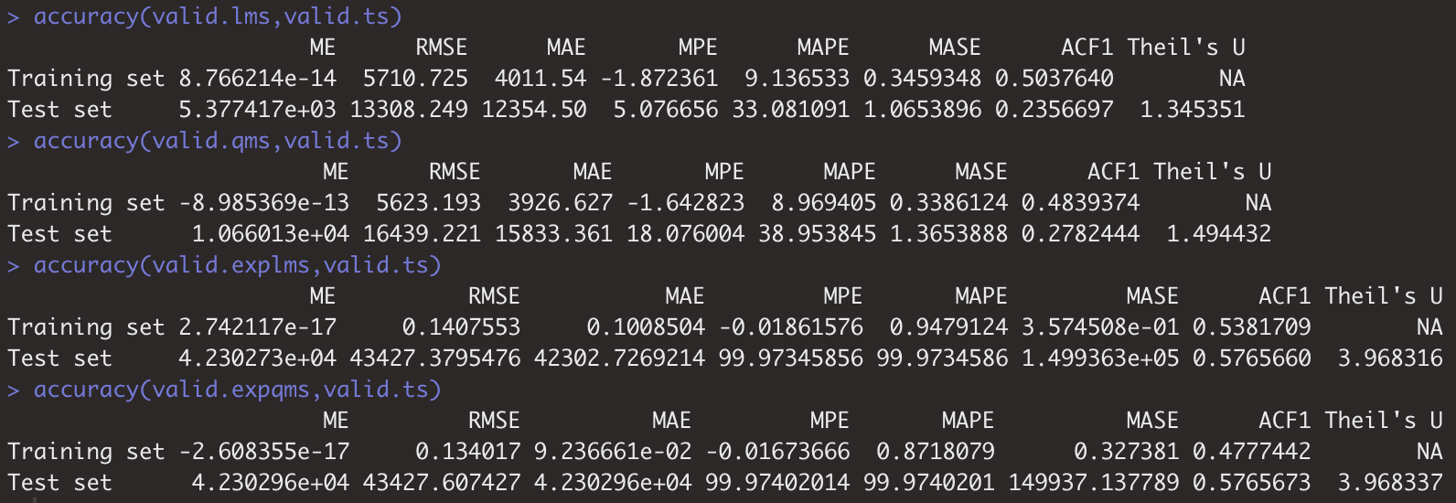

1. ARIMA(2,1,1)

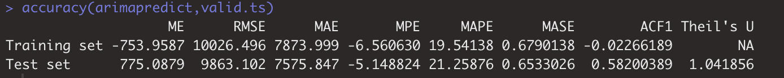

1. Exponential smoothing with seasonality TBATS model

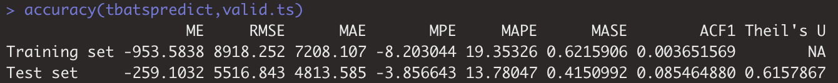

Plot of each model:

|  |  |
| --- | --- |
| Linear trend model | Quadratic trend model |
|  |  |
| Exponential trend model | Linear trend model with seasonality |
|  |  |
| Quadratic trend model with seasonality | Exponential trend model with seasonality |
|  |  |
| ARIMA(2,1,1) | Exponential smoothing with seasonality TBATS model |
|  |  |

* Total gallons of water Building T are expected to use in each of the next four weeks (predicted by exponential smoothing with seasonality TBATS model with all data):

1st week: 56151.51, 2nd week: 60610.92, 3rd week: 63729.25, 4th week: 66464.62

**Objective 2 – Optimization**

**Model Design**

1. Variables Declaration

With the forecasted figures, we can frame the problem for optimization. First, we assign non-negative variables to and to represent the volume of water supplied by the company’s tank and bought from Water Co. for the incoming four weeks, respectively. We also set dummy variables and as the indicators representing which contract we’ll recommend XYZ go for.

On this basis, we also assigned variables to as the tank storage by the end of each week. The formulation of is:

1. Constrains Setting
2. As we have set and as non-negative integers, we further keep them as dummy variables by setting + = 1
4. Objective Function

Our objective is to minimize the total cost for the incoming four weeks. With the previous settings, the objective function is:

**Analysis Solution**



1. In our optimization model result, we recommend XYZ Corporation to accept contract c2 which will **supply water at 12 cents per gallon with a minimum of 35,000 gallons purchased per week.**
2. According to our optimization result, XYZ Corporation will purchase **42,113 gallons on week1; 45,458 gallons on week2; 35,000 gallons on week3; 35,000 gallons on week4**.
3. According to our optimization result, XYZ Corporation’s usage from Water Storage Tank will be **14,038 gallons on week1; 15,153 gallons on week2; 28,729 gallons on week3; 31,464 gallons on week4**.
4. At the end of the next four weeks, XYZ’s projected **total water cost will be 30,182 dollars**.
5. The Water Storage Tank inventory at the end of **week1 will be 60,462 gallons**. The Water Storage Tank inventory at the end of **week2 will be 63,310 gallons**. The Water Storage Tank inventory at the end of **week3 will be 54,581 gallons**. The Water Storage Tank inventory at the end of **week4 will be 45,117 gallons**.
6. The alternative contract (c1) optimization result is as below:



Based on the comparison on the total costs, XYZ saves $34,153 - $30,182 = **$3,971** by choosing the recommended contract over the alternative contract.

1. 45,117 - 30,000 = **15,117 more** **gallons** will be in the Water Storage Tank at the end of the four-week period compared to if the alternative contract was chosen.